|  |
| --- |
| [公司名称] |
| SUMO学习手册 |
| [文档副标题] |

|  |
| --- |
| Jay Zhang  2019-9-20 |

# SUMO简介

## Introduction

# 路网建模（其他方法）

## 三种抽象网络生成

The type of network you want to create must be stated with one of the following switches: **--grid**, **--spider** or **--rand**.

生成网格路网的代码

netgenerate --grid --grid.number=10 --grid.length=400 --output-file=MySUMOFile.net.xml

或者

netgenerate --grid --grid.x-number=20 --grid.y-number=5 \

 --grid.y-length=40 --grid.x-length=200 --output-file=MySUMOFile.net.xml

Optionally, you can omit the central junction of the network by specifying **--spider.omit-center** or **--nocenter**. This also gives an easy way of generating a circle network. Using for instance

netgenerate --spider --spider-omit-center --output-file=MySUMOFile.net.xml

will create a circle consisting of 13 elements with a radius of 100m.

Two examples of usage:

netgenerate --spider --spider.arm-number=10 --spider.circle-number=10 \

 --spider.space-radius=100 --output-file=MySUMOFile.net.xml

and:

netgenerate --spider --spider.arm-number=4 --spider.circle-number=3 \

 --spider.space-radius=100 --output-file=MySUMOFile.net.xml

随机网络

An example:

netgenerate --rand -o MySUMOFile.net.xml --rand.iterations=200

## NETCONVERT路网转换

[NETCONVERT](https://sumo.dlr.de/docs/NETCONVERT.html) is able to import road networks from the following formats:

* ["SUMO native" XML descriptions](https://sumo.dlr.de/docs/Networks/PlainXML.html) (*.edg.xml, *.nod.xml, *.con.xml, *.tll.xml)
* [OpenStreetMap](https://sumo.dlr.de/docs/OpenStreetMap_file.html) (*.osm.xml), including shapes (see [OpenStreetMap import](https://sumo.dlr.de/docs/Networks/Import/OpenStreetMap.html))
* [VISUM](https://sumo.dlr.de/docs/Networks/Import/VISUM.html), including shapes and demands
* [Vissim](https://sumo.dlr.de/docs/Networks/Import/Vissim.html), including demands
* [OpenDRIVE](https://sumo.dlr.de/docs/Networks/Import/OpenDRIVE.html)
* [MATsim](https://sumo.dlr.de/docs/Networks/Import/MATsim.html)
* [SUMO](https://sumo.dlr.de/docs/Networks/Import/SUMO_Road_Networks.html) (*.net.xml)
* [Shapefiles](https://sumo.dlr.de/docs/Networks/Import/ArcView.html) (.shp, .shx, .dbf), e.g. ArcView and newer Tiger networks
* [Robocup Rescue League](https://sumo.dlr.de/docs/Networks/Import/RoboCup.html), including shapes
* [a DLR internal variant of Navteq's GDF](https://sumo.dlr.de/docs/Networks/Import/DlrNavteq.html) (Elmar format)

[NETCONVERT](https://sumo.dlr.de/docs/NETCONVERT.html) is able to export road networks in the following formats:

* [SUMO](https://sumo.dlr.de/docs/Networks/Export.html#sumo) (*.net.xml)
* ["SUMO native" XML descriptions](https://sumo.dlr.de/docs/Networks/Export.html#plain) (*.edg.xml, *.nod.xml, *.con.xml, *.tll.xml)
* [OpenDRIVE](https://sumo.dlr.de/docs/Networks/Export.html#opendrive)
* [MATsim](https://sumo.dlr.de/docs/Networks/Export.html#matsim)
* [a DLR internal variant of Navteq's GDF](https://sumo.dlr.de/docs/Networks/Export.html#dlrnavteq) (Elmar format)
* [a basic network view developed in the Amitran project](https://sumo.dlr.de/docs/Networks/Export.html#amitran)

### 从OpenStreetMap获取数据

The pages [Networks/Import/OpenStreetMap](https://sumo.dlr.de/docs/Networks/Import/OpenStreetMap.html) and [Tutorials/Import from OpenStreetMap](https://sumo.dlr.de/docs/Tutorials/Import_from_OpenStreetMap.html) show how to convert an OpenStreetMap file to a SUMO network file.

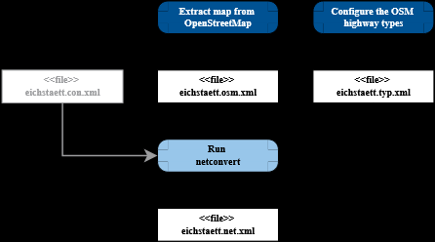

#### 下载OpenStreetMap某个区域数据

1. 直接打开浏览器下载：Data can be downloaded comfortably at http://www.openstreetmap.org/export by selecting a rectangular area.

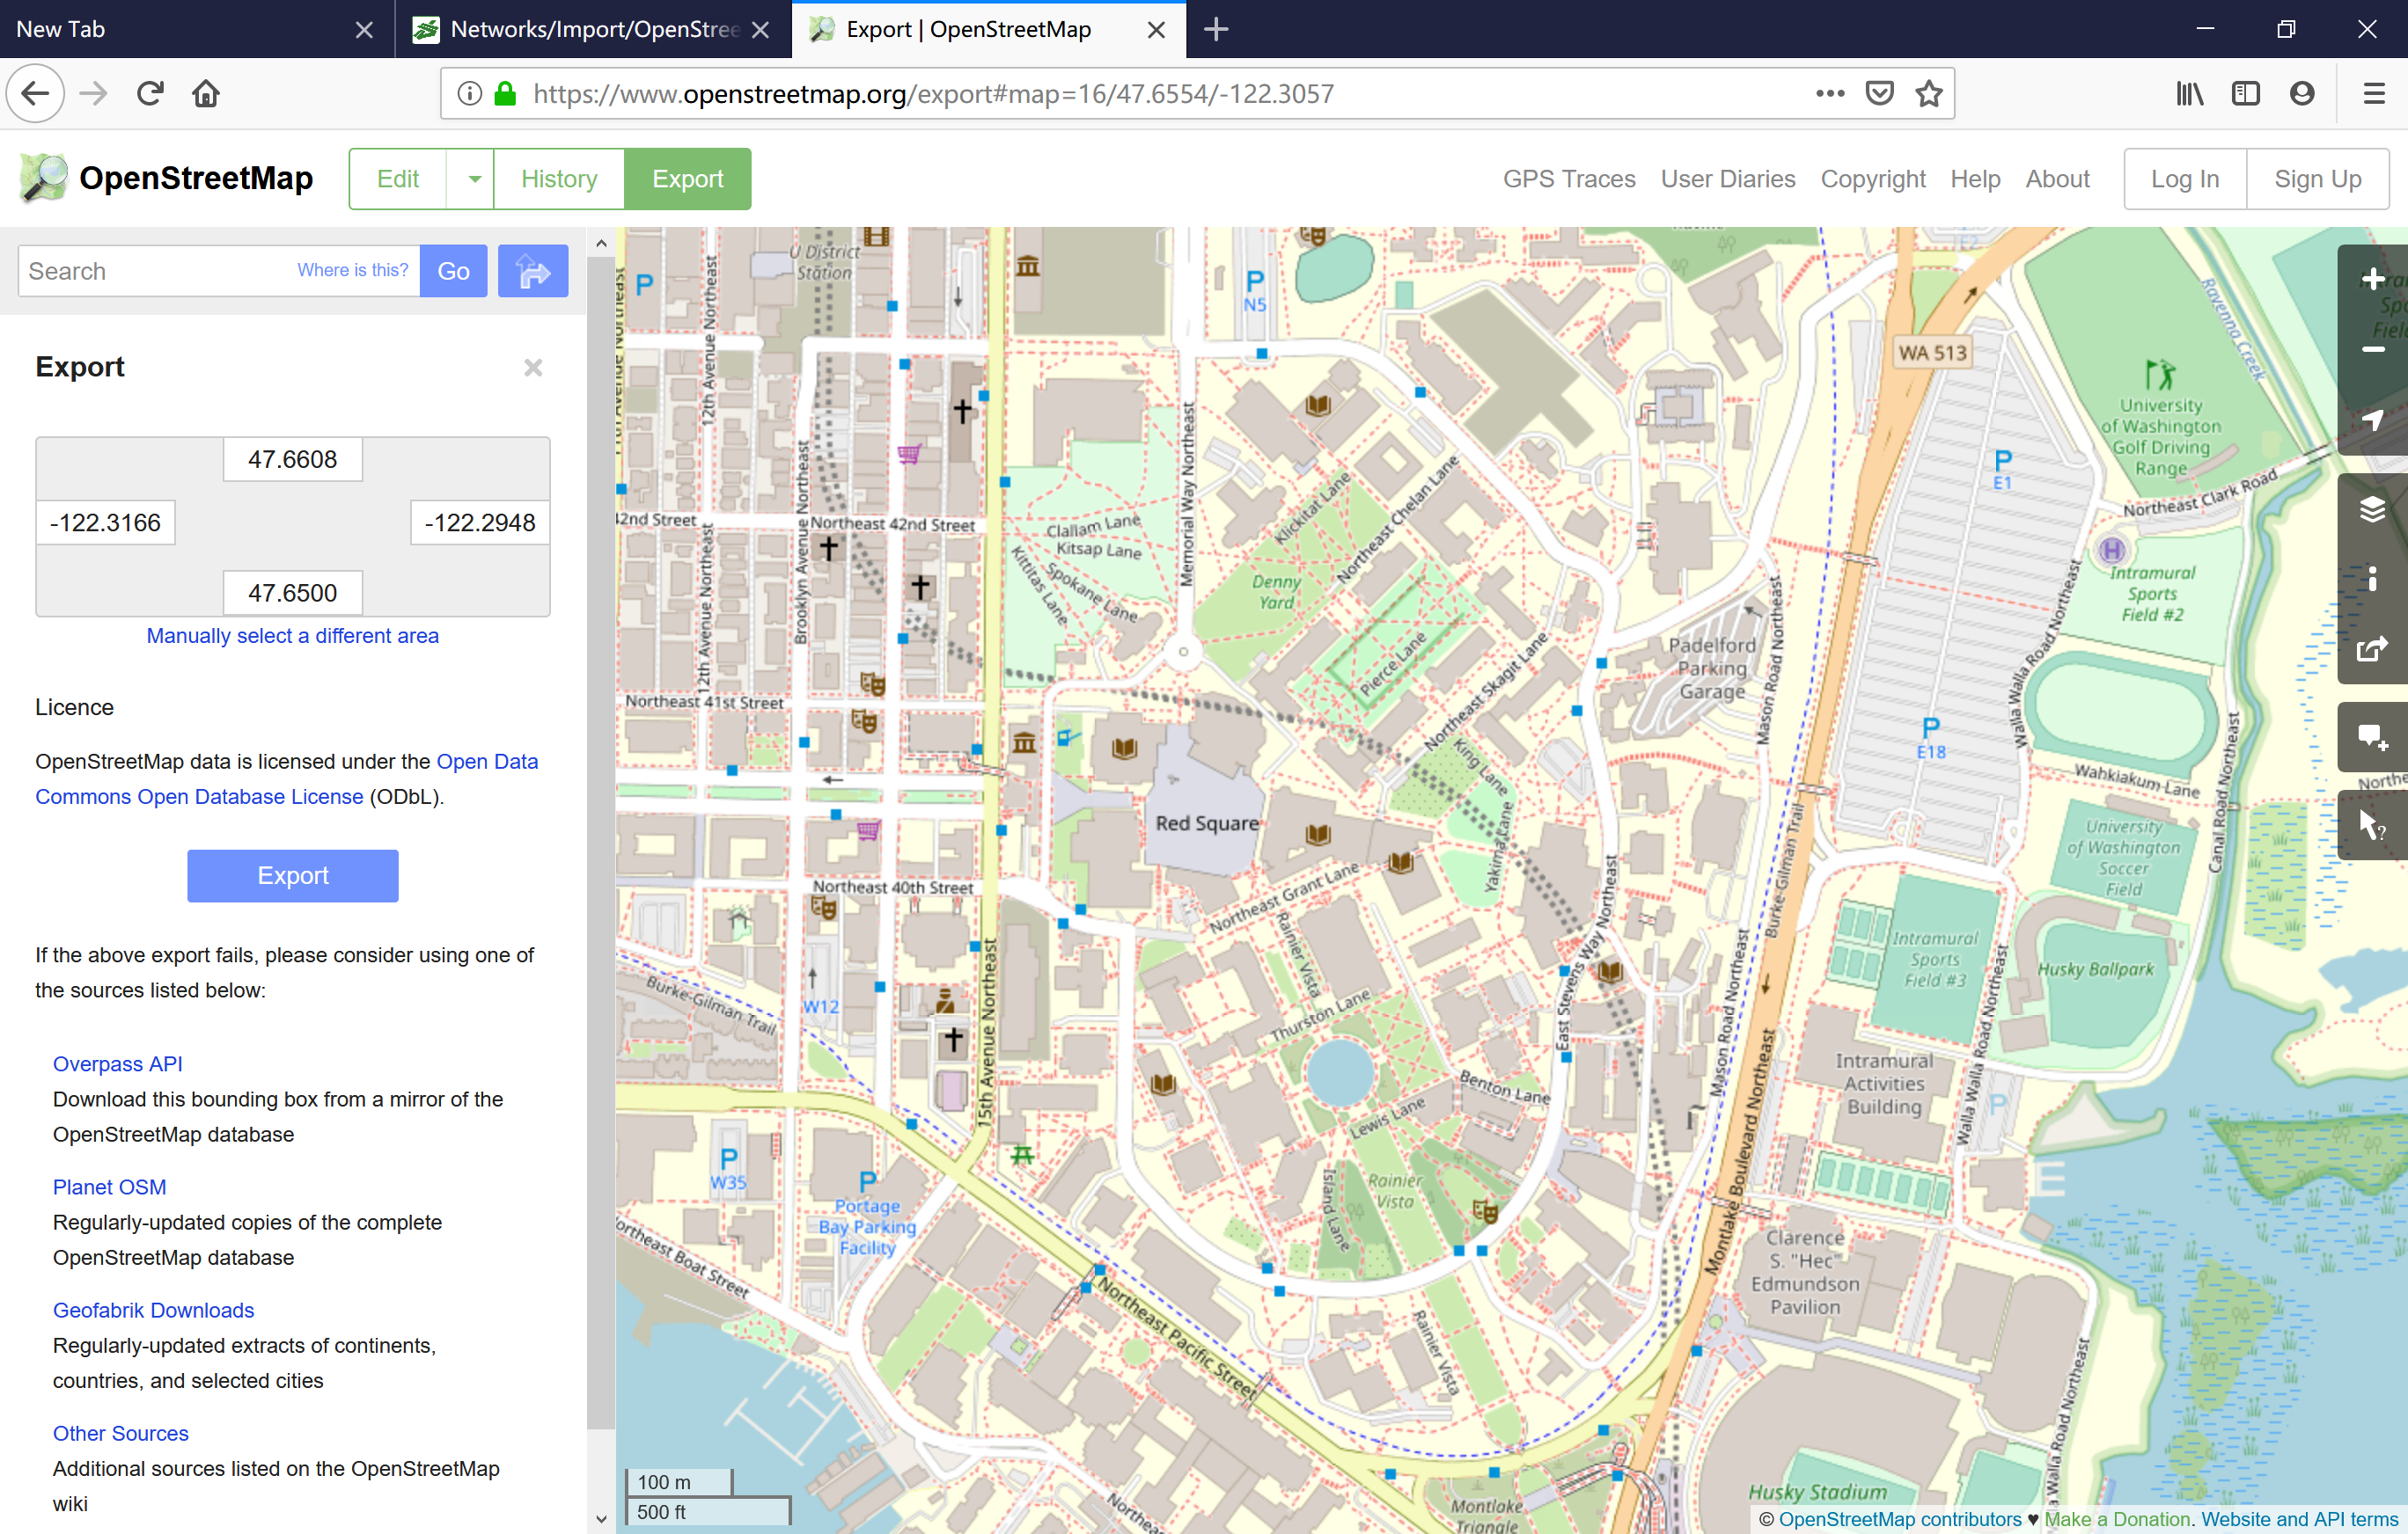

选择“Manually Select a different area”进行选区调整



完成选区调整，点击“Export”完成文件保存（默认文件名：map.osm）

运行命令进行格式转换：  
call="%SUMO_HOME%\bin\netconvert" --osm-files map.osm -o uw.net.xml

用“NETEDIT”打开“uw.net.xml”进行查看

#### 使用osmWebWizard

运行：python "%SUMO_HOME%/tools/osmWebWizard.py"

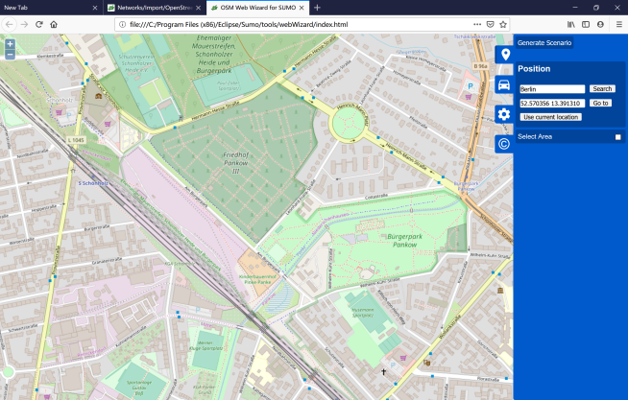

勾选“select area”，然后进行选区调整

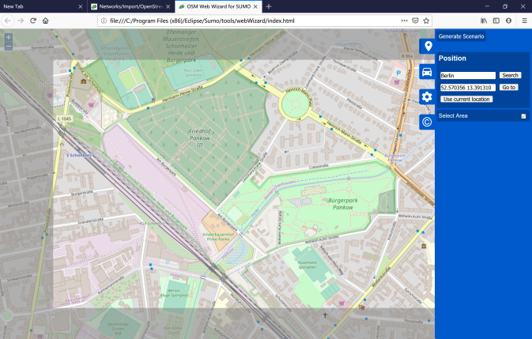

选择Car等信息

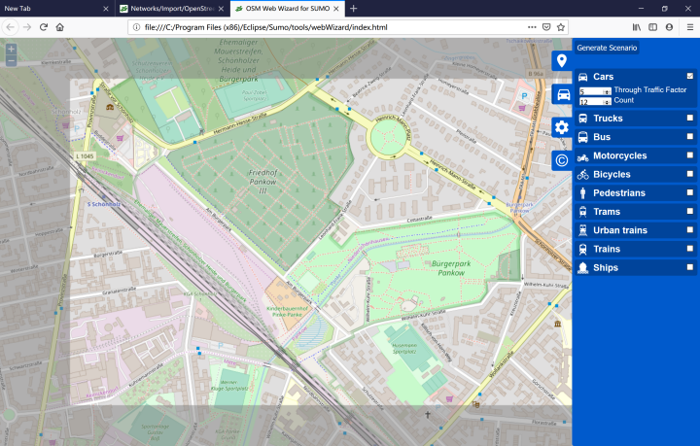

点击“Generate Scenario”进行数据生成，结果将在SUMO中显示

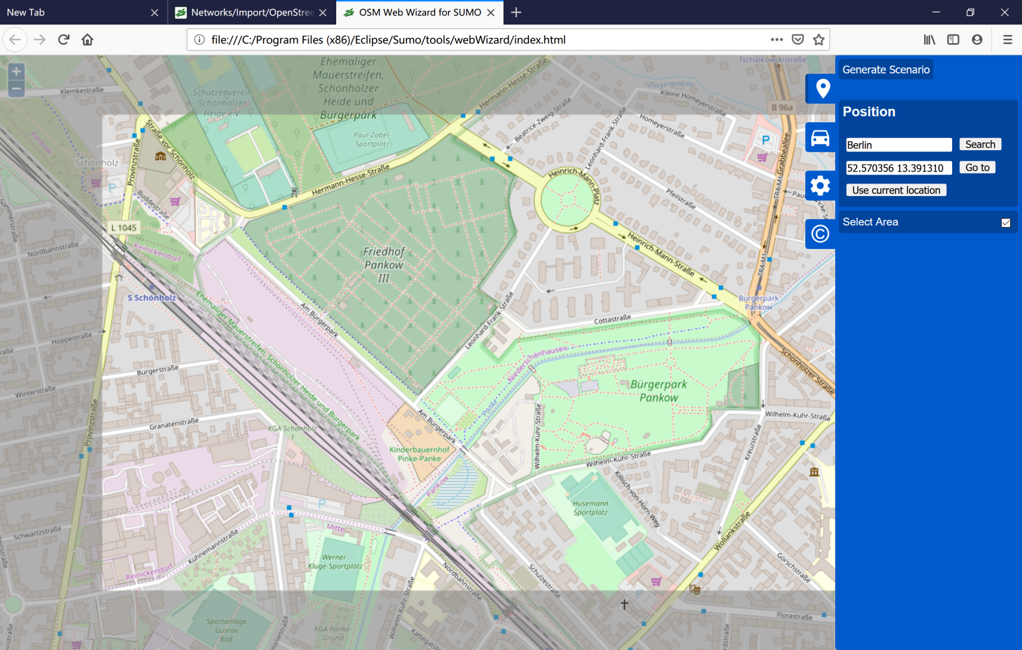

### 从VISSIM文件获取数据

netconvert --vissim-file=<VISSIM_FILE> --output-file=MySUMOFile.net.xml

# 使用NETEDIT创建和调整路网模型

**NETEDIT** is a graphical network editor for SUMO.

* **Purpose:** create and modify SUMO networks
* **System:** portable (Linux/Windows is tested); opens a window
* **Input (optional):** road network definitions to import
* **Output:** A generated SUMO-road network; optionally also other outputs
* **Programming Language:** c++

## 主界面

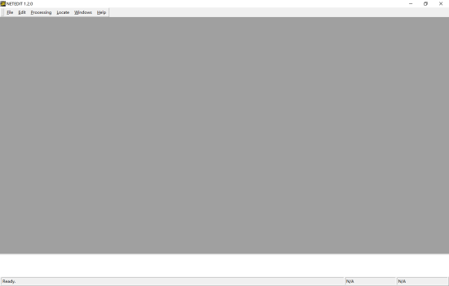

## 加载背景图

打开 visualisation settings，点击 或Edit→Edit Visualisation

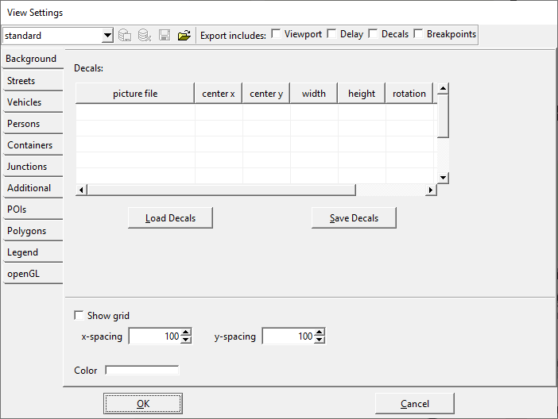

点击"picture file"列空白，输入完整的图片路径（支持png,gif,bmp）

修改**center x**, **center y**, **width**, **height**, and **rotation**.（When setting the column **relative** to 1, position and size values will be taken as screen-relative pixel values instead of network-relative meter values.）

点击"Save Decals"保存到XML

再点击"Load Decals"加载之前保存的XML文件，即可完成背景图加载

|  |  |  |
| --- | --- | --- |
| Attribute Name | Value Type | Description |
| filename | path (string) | *picture file*, the full name of the background image |
| centerX | float | *center x*, the x-position of the center of the image in network coordinates (in meters) |
| centerY | float | *center y*, the y-position of the center of the image in network coordinates (in meters) |
| width | float | The width of the image in network coordinates (in meters) |
| height | float | The height of the image in network coordinates (in meters) |
| rotation | float | The angle of the image in degrees |
| layer | float | The layer at which the image in drawn in meters over ground |
| screenRelative | bool | *relative*, whether the position and size are pixel coordinates relative to the screen rather then the network coordinates |
| centerZ | float | The z-position of the center of the object in network coordinates (in meters), only used in 3D visualization instead of *layer* |
| tilt | float | The tilt angle of the object, only used in 3D visualization |
| roll | float | The roll angle of the object, only used in 3D visualization |

## 新建路网

File→New Network

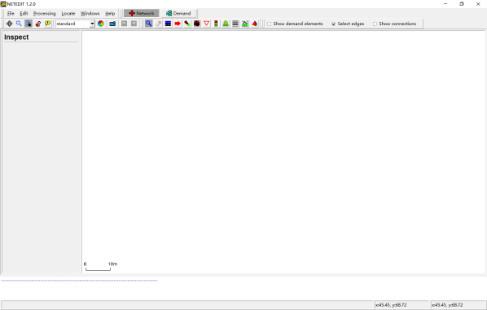

Edit菜单项

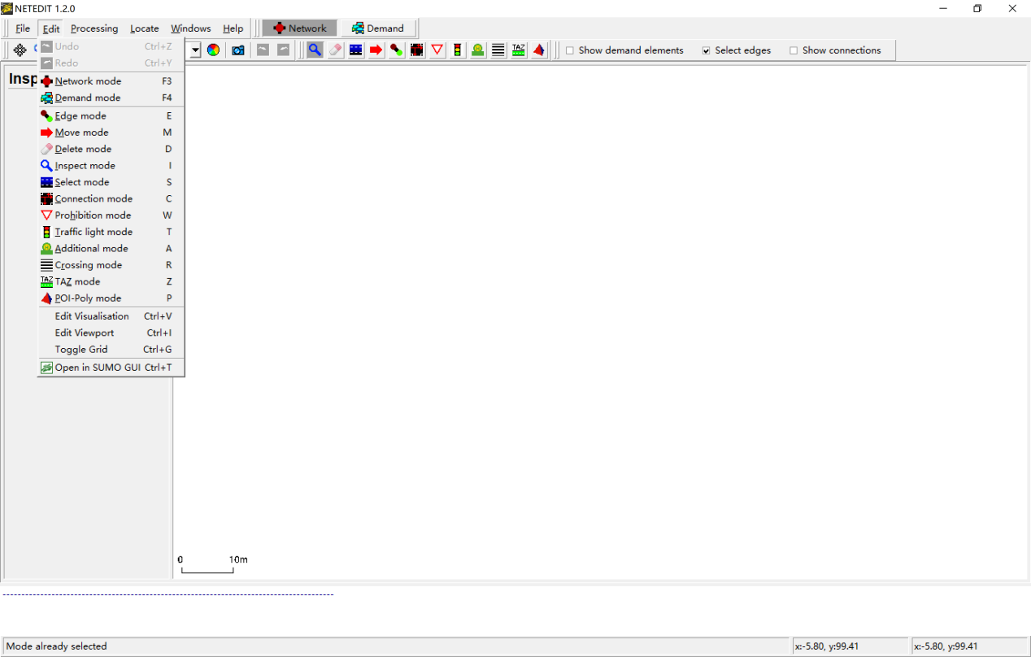

进入Edge mode：

Edit→Network mode

Edit→Edge mode

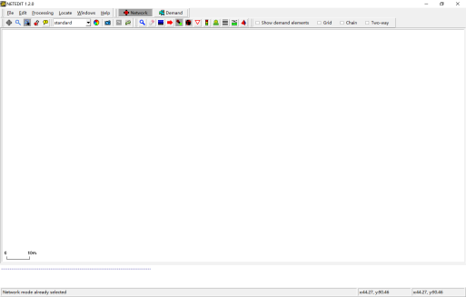

左键点击创建一个节点

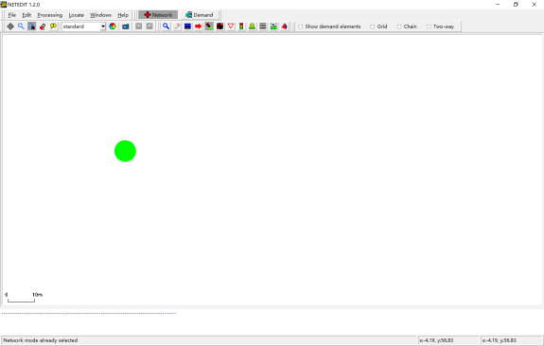

左键点击空白处，创建另一个节点，并自动生成道路

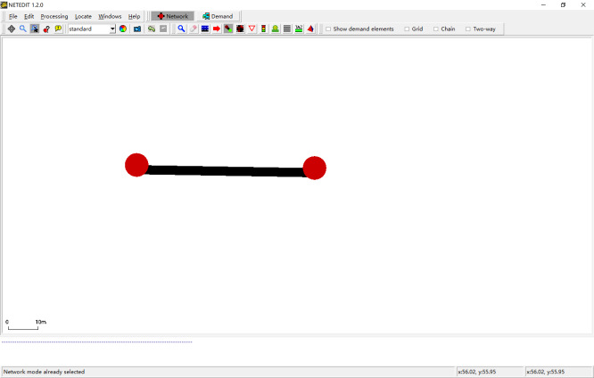

左键点击，选择一个node

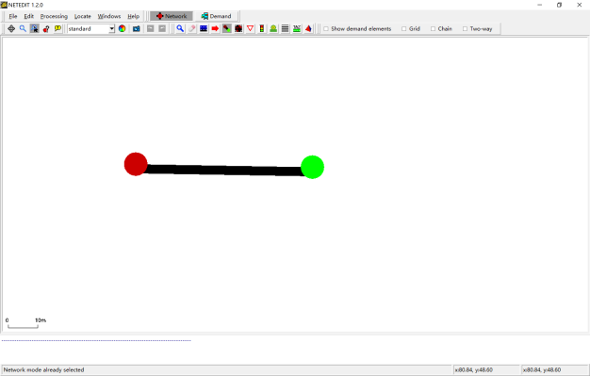

左键点击另一个node，生成对向车道

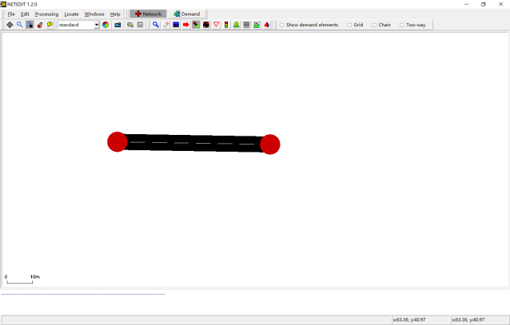

创建另外3个节点，并简单绘制一个十字交叉口

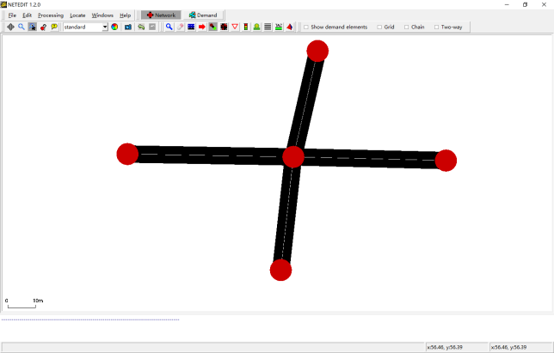

## 修改属性

进入Inspect mode：

Edit→Network mode

Edit→Inspect mode

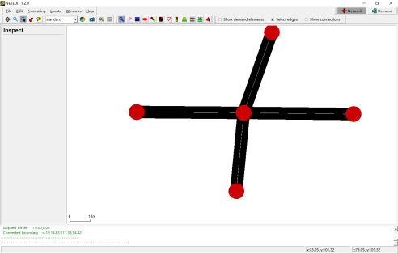

左键点击一个节点，查看信息

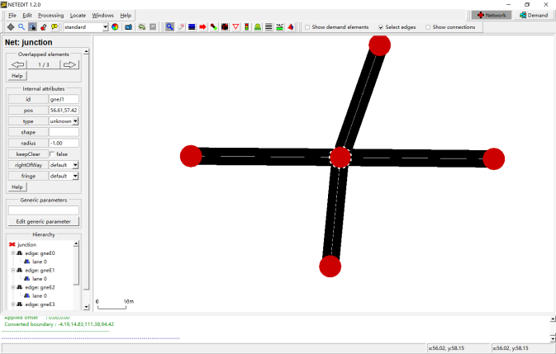

左键点击路段，查看属性

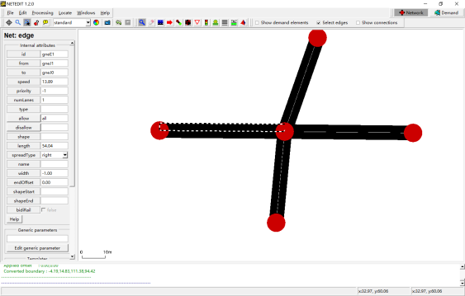

将车道数改成3，numLanes

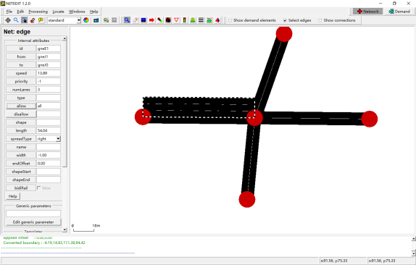

查看允许车型，点击allow，可修改

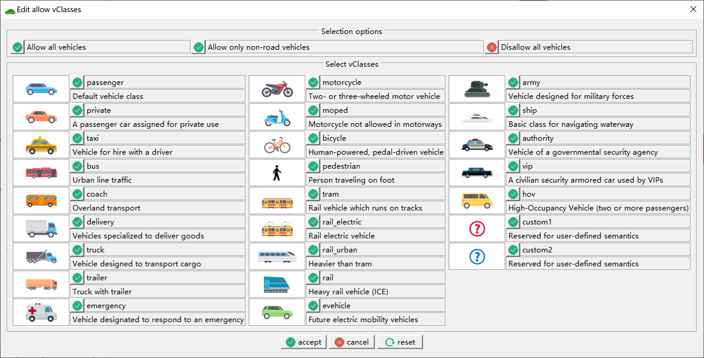

修改所有车道参数

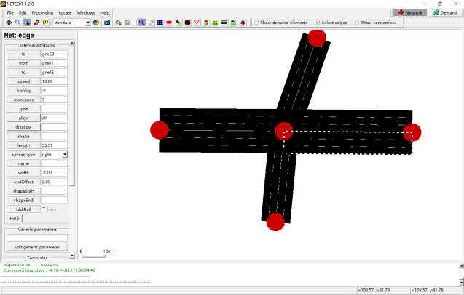

## 调整路网道路

进入Move mode：

Edit→Network mode

Edit→Move mode

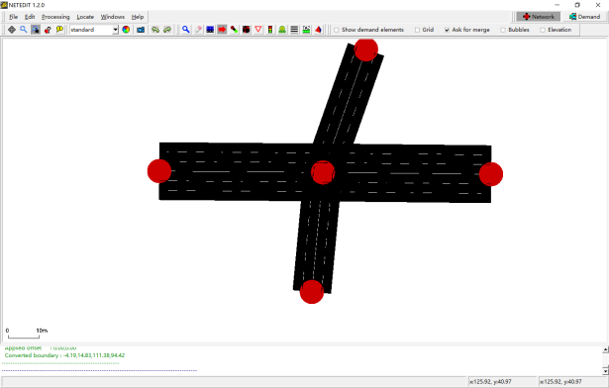

左键拖到节点到新的位置

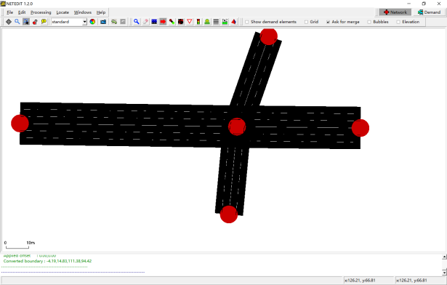

左键移动路段，改变道路几何形状

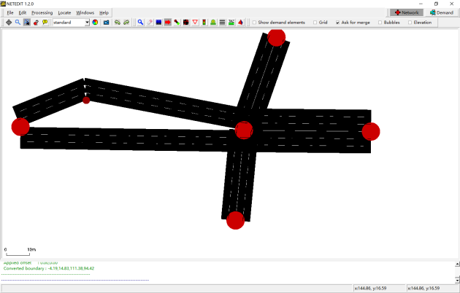

## 设置交叉口流向

进入Connection mode：

Edit→Network mode

Edit→Connection mode

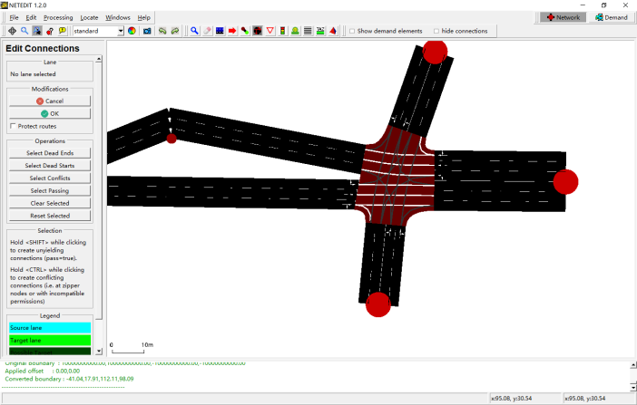

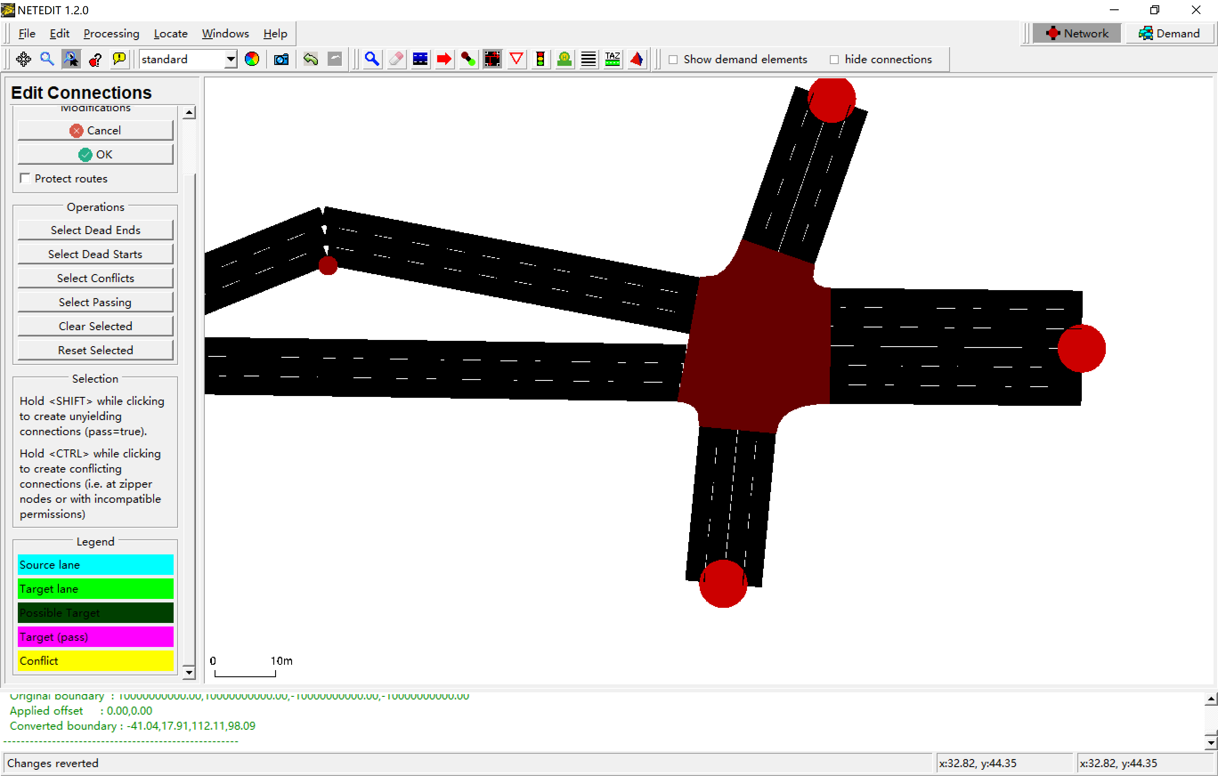

左键选择一个车道

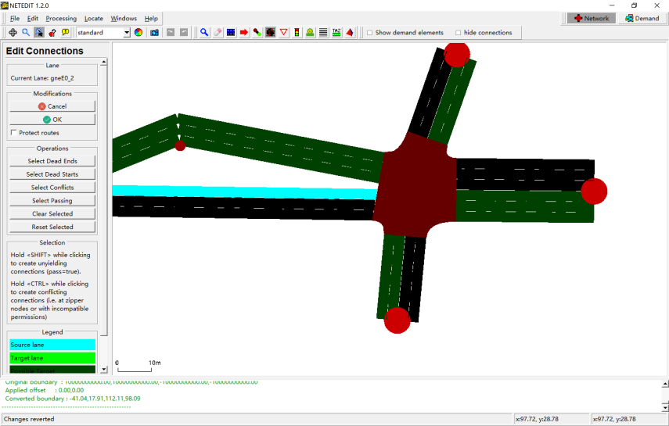

左键点击选择对应的流向车道，可多选

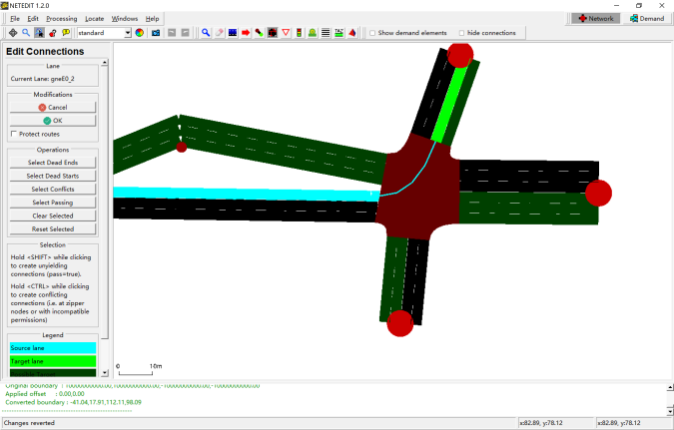

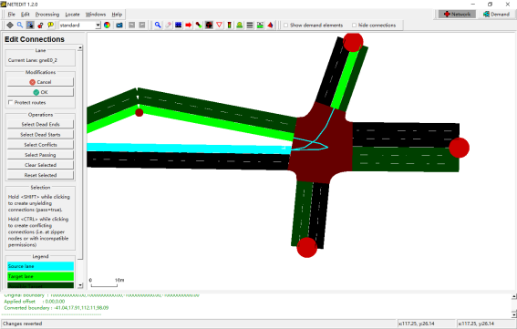

点击OK，进行下一步操作

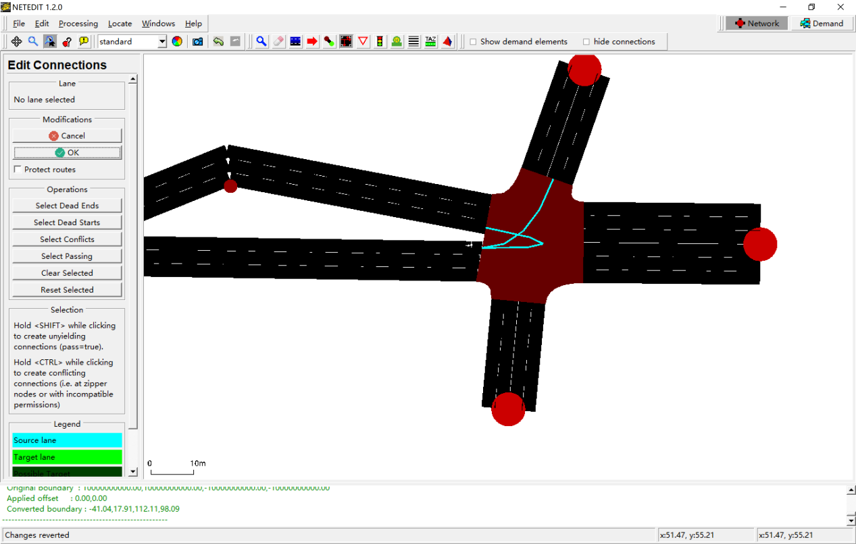

完成所有的流向设置

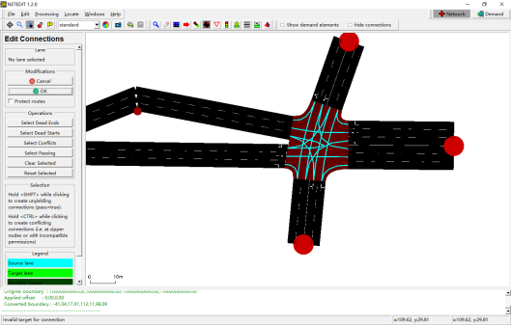

左键选择一个车道

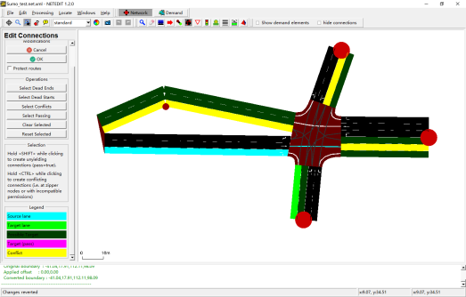

Ctrl+左键，修改冲突车道

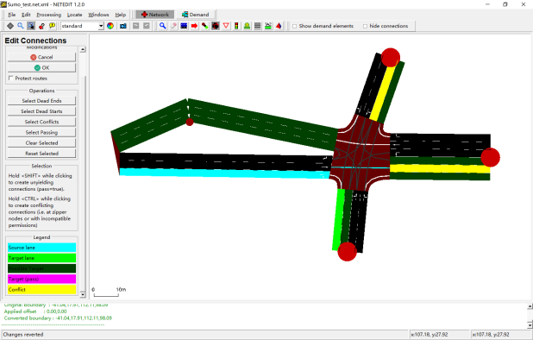

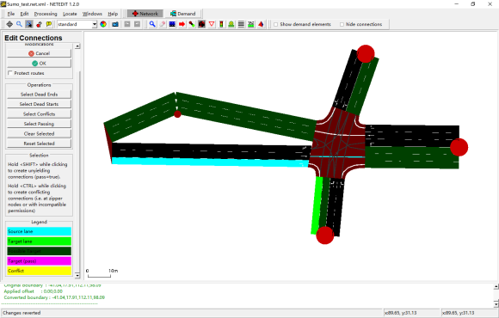

另一个车道

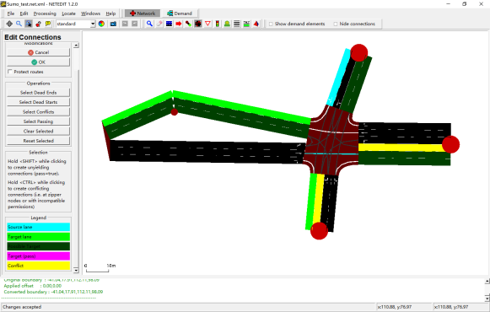

修改后

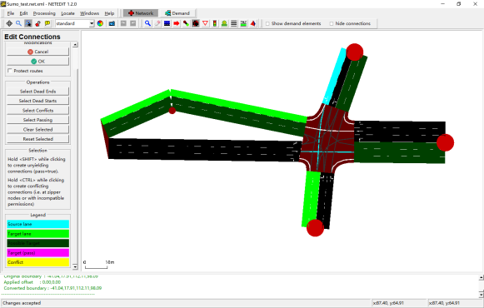

## 创建lane/storage length

创建节点

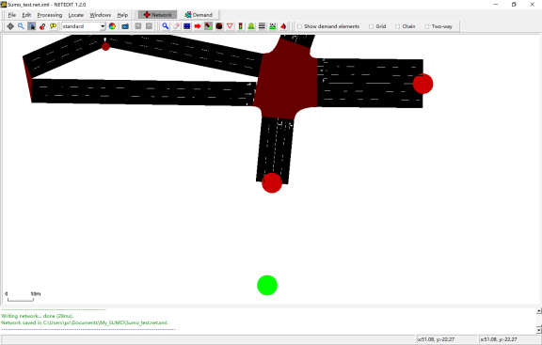

建立连接

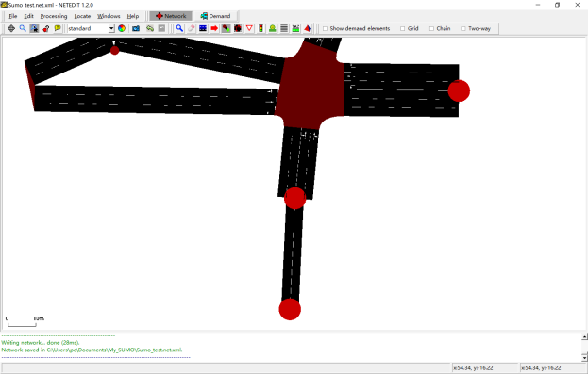

修改属性

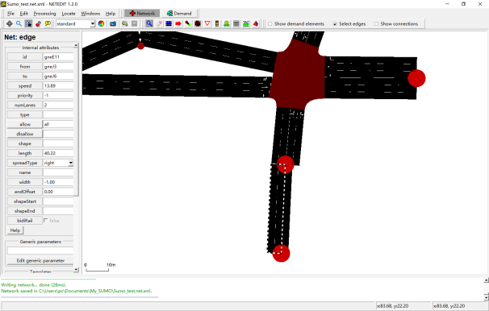

建立连接

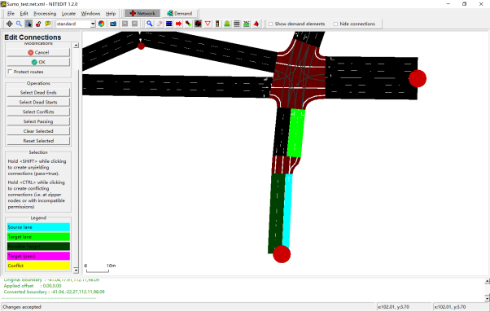

## 修改车道属性：车道宽度、车型等

进入Inspect mode

Shift+左键，选择车道

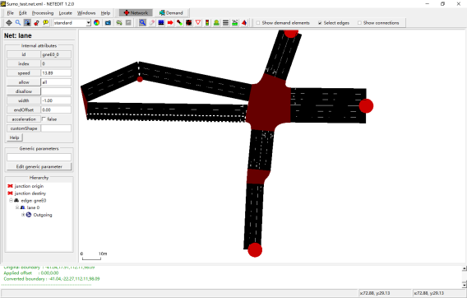

修改车道宽度

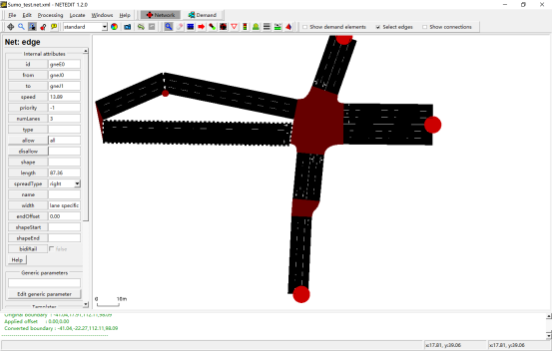

## 添加信号灯

Edit→Network mode

Edit→Traffic light mode

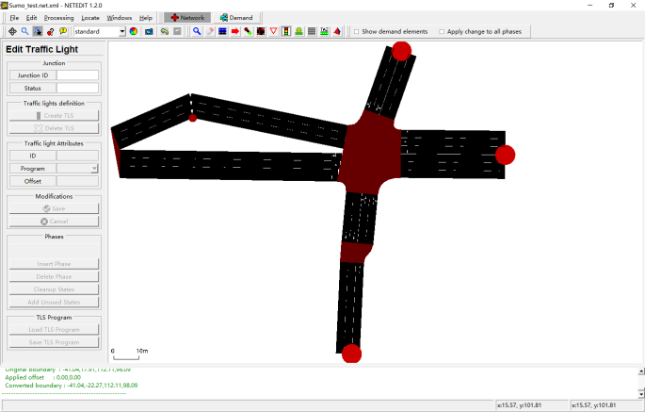

The following signal colors are used:

| **Character** | **GUI Color** | **Description** |
| --- | --- | --- |
| r | FOO | 'red light' for a signal - vehicles must stop |
| y | FOO | 'amber (yellow) light' for a signal - vehicles will start to decelerate if far away from the junction, otherwise they pass |
| g | FOO | 'green light' for a signal, no priority - vehicles may pass the junction if no vehicle uses a higher priorised foe stream, otherwise they decelerate for letting it pass. They always decelerate on approach until they are within the configured [visibility distance](https://sumo.dlr.de/docs/Networks/PlainXML.html#explicitly_setting_which_edge_lane_is_connected_to_which) |
| G | FOO | 'green light' for a signal, priority - vehicles may pass the junction |
| s | FOO | 'green right-turn arrow' requires stopping - vehicles may pass the junction if no vehicle uses a higher priorised foe stream. They always stop before passing. This is only generated for junction type traffic_light_right_on_red. |
| u | FOO | 'red+yellow light' for a signal, may be used to indicate upcoming green phase but vehicles may not drive yet (shown as orange in the gui) |
| o | FOO | 'off - blinking' signal is switched off, blinking light indicates vehicles have to yield |
| O | FOO | 'off - no signal' signal is switched off, vehicles have the right of way |

创建TLS

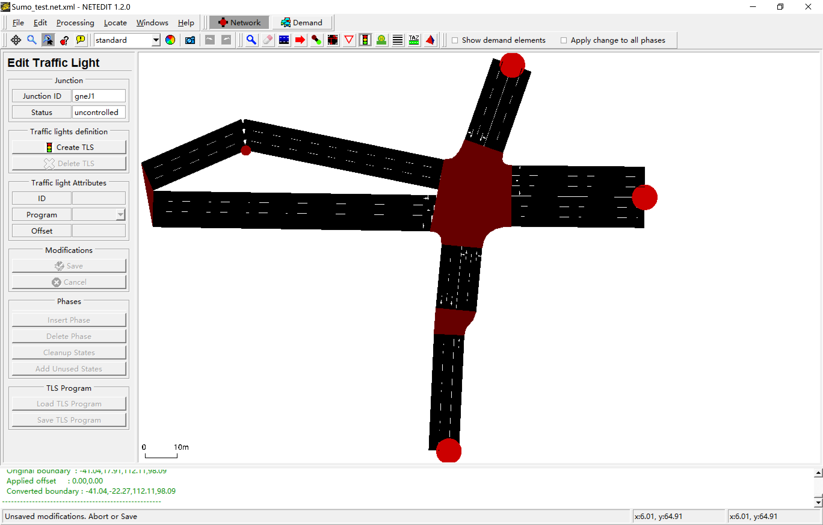

对信号配时方案进行修改

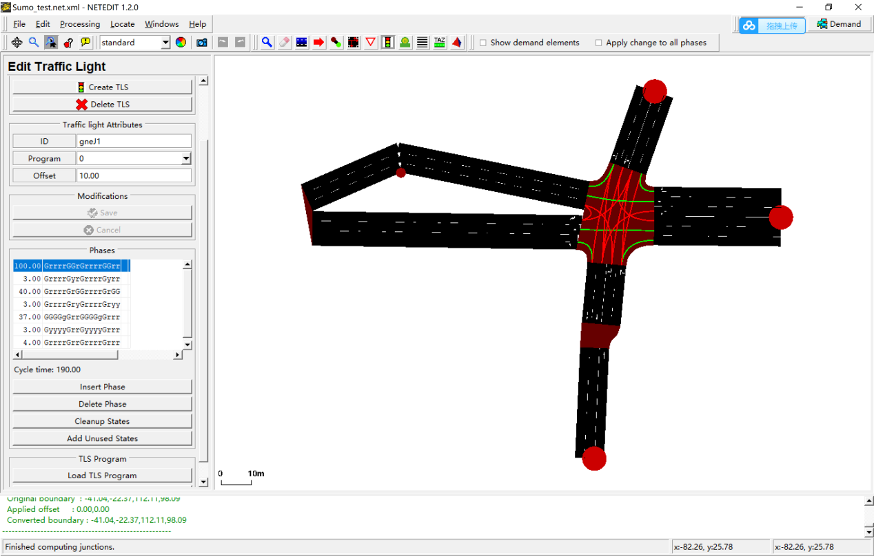

# 交通需求

A **trip** is a vehicle movement from one place to another defined by the starting edge (street), the destination edge, and the departure time. A **route** is an expanded trip, that means, that a route definition contains not only the first and the last edge, but all edges the vehicle will pass.

## 生成随机的车辆路径

Python "%SUMO_HOME%\tools\randomTrips.py" -n Sumo_test.net.xml -o Sumo_test.rou.xml -e 3600 -l

产生的路径中包含了所有可能的路径，因此会有路径和实际模型不符，会导致错误。

## 按流量和路口转向比例生成车辆路径

### 构造流量配置文件Sumo_test.flows.xml

<flowdefs>

<flow id="0" from="gneE0" begin="0" end="1" number="100"/>

<flow id="1" from="gneE10" begin="0" end="1" number="100"/>

<flow id="2" from="gneE2" begin="0" end="1" number="100"/>

<flow id="3" from="gneE7" begin="0" end="1" number="100"/>

</flowdefs>

### 构造路段上的转向比例Sumo_test.turns.xml

<?xml version="1.0" encoding="UTF-8"?>

<turns xmlns:xsi="http://www.w3.org/2001/XMLSchema-instance" xsi:noNamespaceSchemaLocation="http://sumo.dlr.de/xsd/turns_file.xsd">

<interval begin="0" end="10000">

<fromEdge id="gneE0">

<toEdge id="gneE4" probability=".1"/>

<toEdge id="gneE3" probability=".7"/>

<toEdge id="gneE6" probability=".15"/>

<toEdge id="gneE1" probability=".05"/>

</fromEdge>

<fromEdge id="gneE5">

<toEdge id="gneE3" probability=".2"/>

<toEdge id="gneE6" probability=".5"/>

<toEdge id="gneE1" probability=".3"/>

</fromEdge>

<fromEdge id="gneE2">

<toEdge id="gneE6" probability=".2"/>

<toEdge id="gneE1" probability=".5"/>

<toEdge id="gneE4" probability=".3"/>

</fromEdge>

<fromEdge id="gneE7">

<toEdge id="gneE1" probability=".1"/>

<toEdge id="gneE4" probability=".5"/>

<toEdge id="gneE3" probability=".4"/>

</fromEdge>

</interval>

</turns>

### 用JTRROUTER生成车辆路径文件

%SUMO_HOME%\bin\jtrrouter -n Sumo_test.net.xml -r Sumo_test.flows.xml -t Sumo_test.turns.xml -o Sumo_test.rou.xml --accept-all-destinations=t

# 构造sumocfg文件

<?xml version="1.0" encoding="UTF-8"?>

<!-- generated on Tue Apr 16 00:19:19 2019 by Eclipse SUMO Version 1.2.0

This data file and the accompanying materials

are made available under the terms of the Eclipse Public License v2.0

which accompanies this distribution, and is available at

http://www.eclipse.org/legal/epl-v20.html

SPDX-License-Identifier: EPL-2.0

-->

<configuration xmlns:xsi="http://www.w3.org/2001/XMLSchema-instance" xsi:noNamespaceSchemaLocation="http://sumo.dlr.de/xsd/sumoConfiguration.xsd">

<input>

<net-file value="input_net.net.xml"/>

<route-files value="input_net.rou.xml"/>

</input>

</configuration>

运行该文件即可进行仿真。

# 采集输出数据（sumocfg文件）

添加路段检测器additional_detect_params.add.xml

<additional>

<inductionLoop id="myLoop1" lane="gneE0_1" pos="42" freq="100" file="out.xml"/>

<inductionLoop id="myLoop2" lane="gneE5_1" pos="10" freq="100" file="out.xml"/>

</additional>

添加输出数据

<output>

<write-license value="true"/>

<queue-output value="output_queue.xml"/>

<emission-output value="output_emission"/>

<full-output value="output_full-output"/>

<vtk-output value="output_VTK" />

</output>

格式转换：

Python "%SUMO_HOME%\tools\xml\xml2csv.py" output_full-output

Python "%SUMO_HOME%\tools\xml\xml2csv.py" output_queue.xml

# TraCI手册TraCI (On-line Interaction)

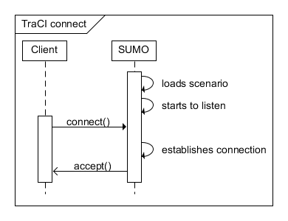

Figure:TraCI: establishing a connection to SUMO

## 安装Python开发环境PyCharm

Python学习资料：<https://www.learnpython.org/en/Hello,_World!>

## 代码实现：配置、启动仿真

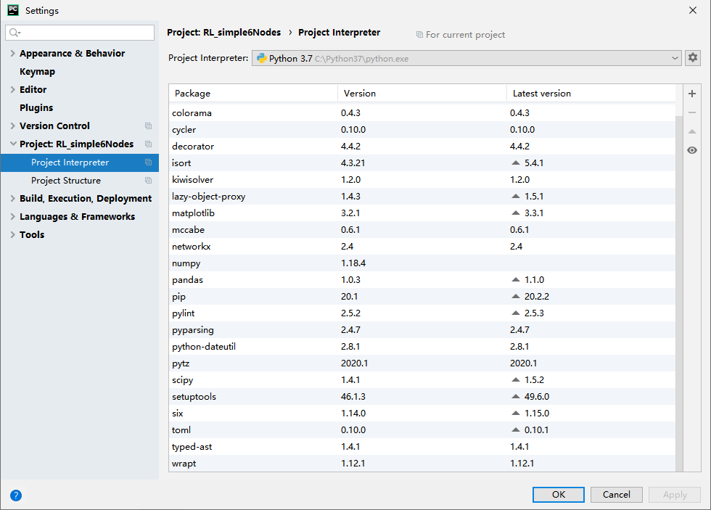

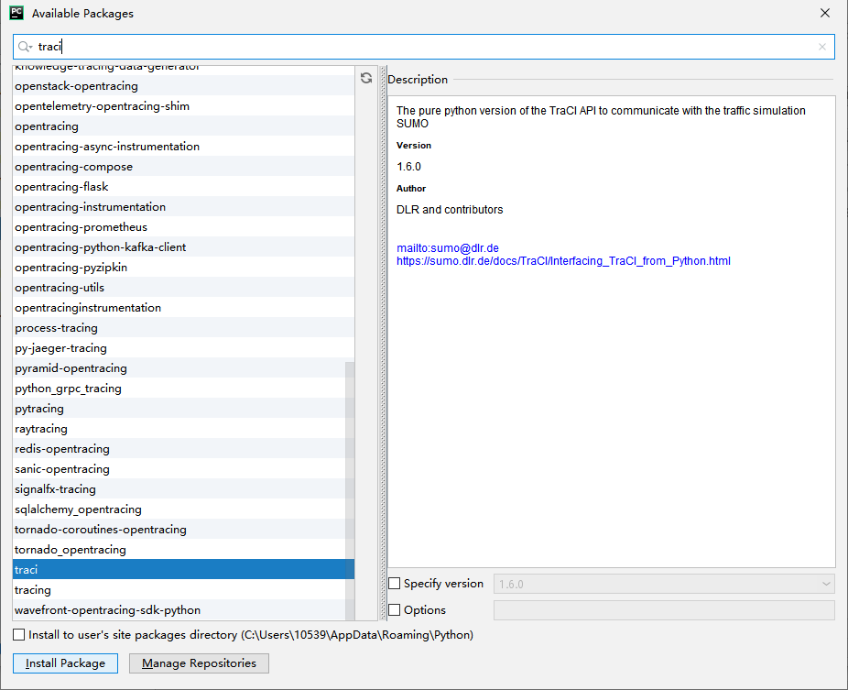

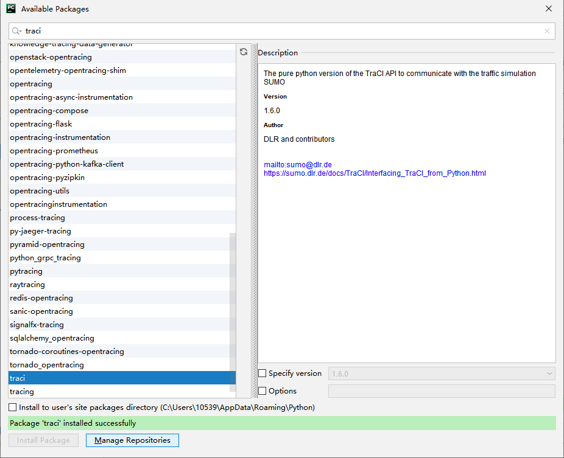

启动已经完成的仿真，单步运行：

**import** sys  
**import** os  
*# """ Import SUMO library """***if 'SUMO_TOOLS' in** os.environ:  
 sys.path.append(os.environ[**'SUMO_TOOLS'**])  
 **import** traci  
 **import** traci.constants **as** tc  
**else**:  
 sys.exit(**"Please declare environment variable 'SUMO_TOOLS'"**)  
*##-------*sumoCmd = [**"sumo"**, **"-c"**, **"C:/Users/pc/Documents/My_SUMO/test2/Sumo_test.sumocfg"**]  
*#*traci.start(sumoCmd)  
step = 0  
**while** step < 1000:  
 traci.simulationStep()step += 1

运行仿真之前要先配置SUMO_HOME及路径：

**import** os, sys  
  
**if 'SUMO_HOME' in** os.environ:  
 tools = os.path.join(os.environ[**'SUMO_HOME'**], **'tools'**)  
 sys.path.append(tools)  
**else**:  
 sys.exit(**"please declare environment variable 'SUMO_HOME'"**)

## 代码实现：读取参数

sumoCmd = [**"sumo-gui"**, **"-c"**, **"C:/Users/pc/Documents/My_SUMO/test2/Sumo_test.sumocfg"**, **'--start'**]  
*#*traci.start(sumoCmd)  
step = 0  
  
*#Run a simulation until all vehicles have arrived  
# 所有的车辆都达到之后仿真结束***while** traci.simulation.getMinExpectedNumber() > 0:  
 print(**"step"**, step)  
 step+=1  
 traci.simulationStep()  
  
traci.close()

*# Define a route that consists of the start and destination edge:*traci.route.add(**"trip"**, [**"gneE0"**, **"gneE6"**])*#  
# Then add the vehicle with that route*traci.vehicle.add(**"newVeh"**, **"trip"**, typeID=**"reroutingType"**)

*# 把半径设的足够大，就能获取整个路网中的所有车辆ID*traci.junction.subscribeContext(junctionID, tc.CMD_GET_VEHICLE_VARIABLE, 1000000, [tc.VAR_SPEED, tc.VAR_ALLOWED_SPEED])  
stepLength = traci.simulation.getDeltaT()  
  
**while** traci.simulation.getMinExpectedNumber() > 0:  
 traci.simulationStep()  
 scResults = traci.junction.getContextSubscriptionResults(junctionID)  
 halting = 0  
 **if** scResults:  
 relSpeeds = [d[tc.VAR_SPEED] / d[tc.VAR_ALLOWED_SPEED] **for** d **in** scResults.values()]  
 *# compute values corresponding to summary-output* running = len(relSpeeds)  
 halting = len([1 **for** d **in** scResults.values() **if** d[tc.VAR_SPEED] < 0.1])  
 meanSpeedRelative = sum(relSpeeds) / running  
 timeLoss = (1 - meanSpeedRelative) * running * stepLength  
 print(traci.simulation.getTime(), timeLoss, halting)

*#获取路口ID的信息*traci.junction.subscribeContext(junctionID, tc.CMD_GET_VEHICLE_VARIABLE, 42, [tc.VAR_SPEED, tc.VAR_WAITING_TIME])*#all vehicle speeds and waiting times within range (42m)*print(traci.junction.getContextSubscriptionResults(junctionID))  
*#获取车辆ID的信息*traci.vehicle.subscribe(vehID, (tc.VAR_ROAD_ID, tc.VAR_LANEPOSITION,tc.VAR_SPEED,tc.VAR_DISTANCE,tc.VAR_TIME))  
print(traci.vehicle.getSubscriptionResults(vehID))  
**for** step **in** range(100):  
 print(**"step"**, step)  
 traci.simulationStep()  
 print(traci.vehicle.getSubscriptionResults(vehID))  
 print(traci.junction.getContextSubscriptionResults(junctionID))

print(**"序 号："**, traci.trafficlight.getPhase(**'gneJ1'**))*#获得相位序号*print(**"相位长度："**, traci.trafficlight.getPhaseDuration(**'gneJ1'**))*#返回当前相位时长*print(**"相位名称："**, traci.trafficlight.getPhaseName(**'gneJ1'**))*#相位名称  
#print(traci.trafficlight.getProgram('gneJ1'))*print(**"相位设置："**, traci.trafficlight.getRedYellowGreenState(**'gneJ1'**))*#当前相位每个流向红黄绿状态  
print(traci.trafficlight.getCompleteRedYellowGreenDefinition('gneJ1'))*print(traci.trafficlight.getNextSwitch(**'gneJ1'**))

## 代码实现：修改参数

*#修改信号配时数据* traci.trafficlight.setPhaseDuration(**'gneJ1'**, 10.0)  
 traci.trafficlight.setPhaseName(**'gneJ1'**,**'Phasetest'**)  
 traci.trafficlight.setProgram(**'gneJ1'**, **'0'**)  
 traci.trafficlight.setRedYellowGreenState(**'gneJ1'**,**'GGGGGGGGGrrGGGGrr'**)